Ex no 16

Date:

**AIM:**

To create a stored procedure Get customer level() that accepts to parameters customer number and customer level.

1. To create a procedure get customer level ():

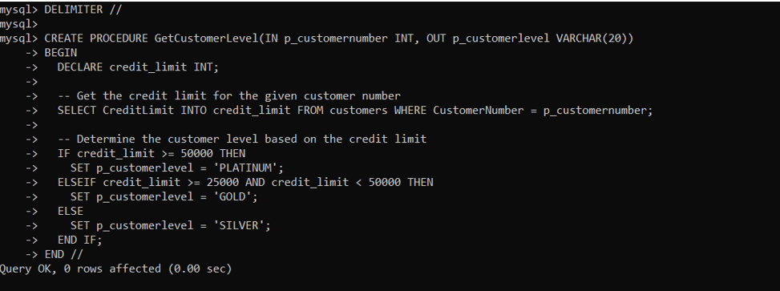

1. To create a table called customer:

````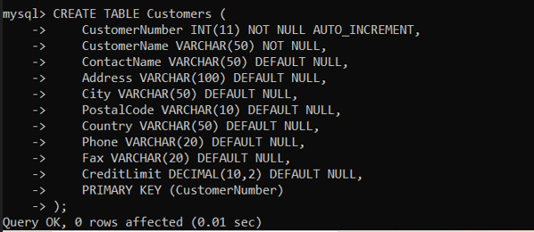

1. To get and declare customer level:

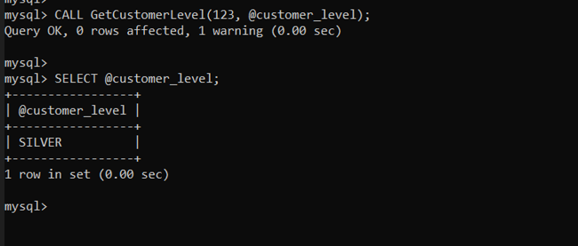

**Conclusion:**

A stored procedure Get customer level() that accepts to parameters customer number and customer level